https://www.jdoodle.com/embed/v0/6d4A
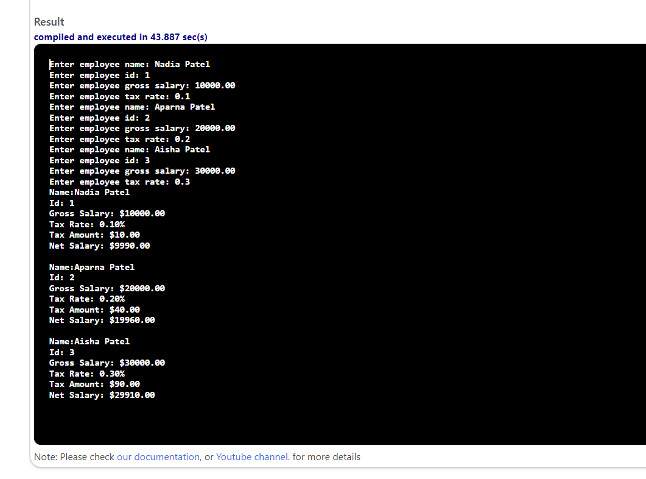

#include <iostream>
#include <iomanip>

using namespace std;

struct Employee
{
string name;
int id;
double grossSalary;

double taxRate;
double taxAmount;
double netSalary;
};

void inputEmployees(Employee emp[], int length)
{
for (int i = 0; i < length; i++)
{
cout << "Enter employee name: ";
getline(cin, emp[i].name);
cout << "Enter employee id: ";
cin >> emp[i].id;
cin.ignore(); //
cout << "Enter employee gross salary: ";
cin >> emp[i].grossSalary;
cout << "Enter employee tax rate: ";
cin >> emp[i].taxRate;
cin.ignore();
}
}

void computeTaxes(Employee emp[], int length)
{
for (int i = 0; i < length; i++)
{
emp[i].taxAmount = emp[i].grossSalary * (emp[i].taxRate / 100.0);
}
}

void computeNetSalaries(Employee emp[], int length)
{
for (int i = 0; i < length; i++)
{
emp[i].netSalary = emp[i].grossSalary - emp[i].taxAmount;
}
}

void displayEmployees(Employee emp[], int length)
{
for (int i = 0; i < length; i++)
{
cout << fixed << showpoint << setprecision(2);
cout << "Name: " << emp[i].name << endl;
cout << "Id: " << emp[i].id << endl;
cout << "Gross Salary: $" << emp[i].grossSalary << endl;
cout << "Tax Rate: " << setprecision(2) << emp[i].taxRate << "%" << endl;
cout << "Tax Amount: $" << emp[i].taxAmount << endl;
cout << "Net Salary: $" << emp[i].netSalary << endl
<< endl;
}
}

int main()
{
const int length = 3;
Employee emp[length];

inputEmployees(emp, length);
computeTaxes(emp, length);
computeNetSalaries(emp, length);
displayEmployees(emp, length);

return 0;
}

